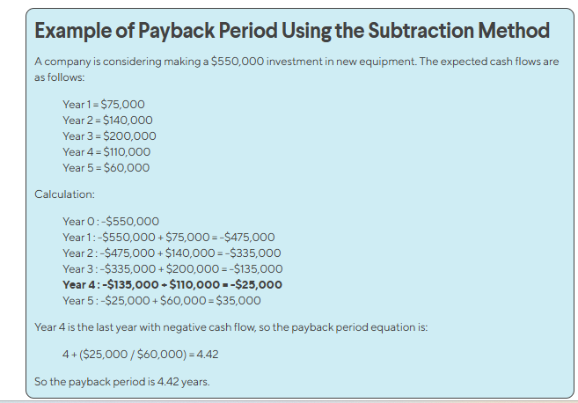

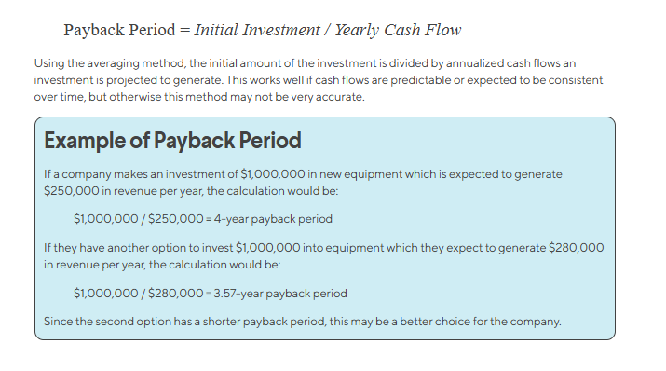

## **Discounted Payback Period - A Business Case:**

The following business case is designed for students to apply their knowledge of the Discounted Payback Period technique in a real-life context.

#### **Case:**

You are an accountant for Boomer Investments Inc., an investment firm that is headquartered in the heart of New York City. Boomer is one of the most successful, diversified investment firms that prides itself on exceptional decision-making and stellar investment opportunities through its global network.

The company's chief financial officer, Johnny Money, asked that you follow him into his office for a meeting.

"Today is a big day for you. You have proven yourself to be an outstanding apprentice when participating in our capital budgeting sessions. It is now the time to take on your first independent analysis. We have the opportunity to invest in Bling Bling Mazoo, a gold mine located in South Africa. We know that there is huge potential here, but as you know we have a strict investment policy regarding the payback period. Specifically, the board will **only** approve investments that have a discounted payback period of **4 years or less**. Can you tell us if this project reaches the board's criteria?"

You receive the following information.

|  |  |
| --- | --- |
| Discount rate (after-tax) | 10% |
| Initial investment | $5,000,000 |
| Net annual cash flow, years 1-3 | $900,000 |
| Net annual cash flow, years 4-10 | $2,600,000 |
| Useful life of the mining project | 10 years |
| Salvage value of investment | $1 |

#### **Required:**

Determine the discounted payback period (Round to 1 decimal) and determine whether or not the project meets the board's requirement.

#### **Solution:**

|  |  |  |  |  |
| --- | --- | --- | --- | --- |
| **Year** | **Net cash flow** | **Present value factor (Note 1)** | **Discounted cash flow ($)** | **Cumulative discounted cash flow ($)** |
| 0 | -5,000,000 | 1 | -5,000,000 | -5,000,000 |
| 1 | 900,000 | 0.9090 | 818,100 | -5,000,000 + 818,100 = -4.181.900 |
| 2 | 900,000 | 0.8264 | 743,760 | -4.181.900 + 743,760 = -3,438,140 |
| 3 | 900,000 | 0.7513 | 676,170 | -3,438,140 + 676,170 = -2,761,970 |
| 4 | 2,600,000 | 0.6830 | 1,953,380 | -2,761,970 + 1,953,380 = -808,590 |
| 5 | 2,600,000 | 0.6209 | 1,614,340 | -808,590 + 1,614,340 = 805,750 (**positive!**) |

Discounted payback period = 4 + 808,590 / 1,614,340 = 4.5 years (more than 4 years)

The answer is **no**, the project does not meet the board's criteria of a discounted payback period of 4 years or less.

*Note 1:*

Present value factor = 1 / (1 + 10%)^number of years

**ROI Calculation**

|  |  |  |
| --- | --- | --- |
| Year | Cash-flow | Accumulated |
| 0 | -100,000 | -100,000 |
| 1 | 10,000 | -90,000 |
| 2 | 10,000 | -80,000 |
| 3 | 10,000 | -70,000 |
| 4 | 20,000 | -50,000 |
| 5 | 100,000 | 50,000 |

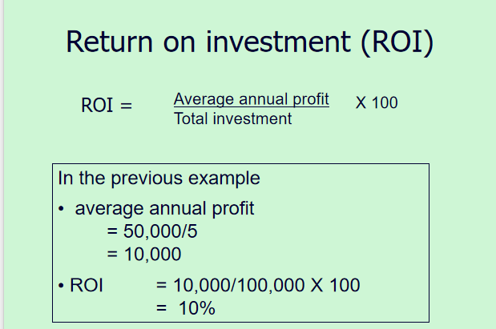

**NPV Calculation**

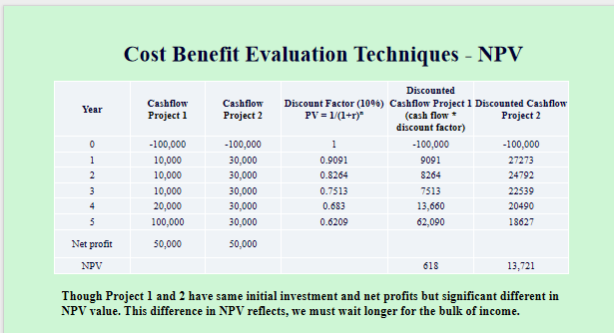

**IRR Calculation**

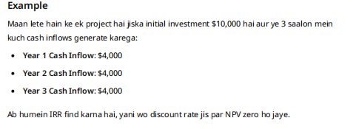

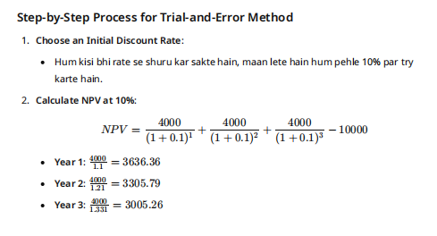

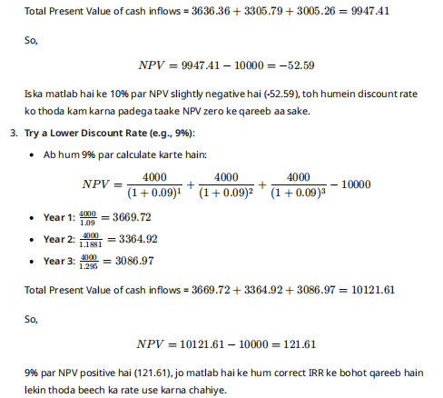

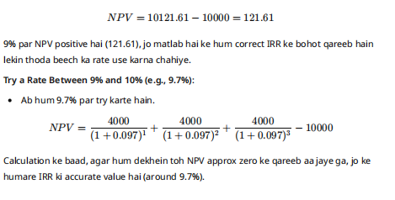

### Cost-benefit analysis sample

Here’s an example of a cost-benefit analysis by a software company looking to upgrade its current customer relationship management (CRM) system. The two options being considered are:

* Option A: Upgrade to a more advanced CRM system that has enhanced features and capabilities and an easy learning curve
* Option B: Stick with the current CRM system and invest in additional training for employees to optimize its use

Here’s a simple version of what the cost-benefit analysis for each option may look like:

**Option A: Upgrade to a more advanced CRM system**

Benefits:

* Improved customer service and relationship management capabilities: $150,000 per year
* Increased efficiency and productivity: $100,000 per year
* Ability to analyze customer data and generate insights: $75,000 per year

Total estimated annual benefit: $325,000

Costs:

* Upfront cost of a new system: $150,000
* Implementation and training costs: $50,000
* Ongoing maintenance and support costs: $75,000 per year

Total annual cost: $275,000

Net annual benefit: $50,000

**Option B: Invest in additional training for the current CRM system**

Benefits:

* Increased employee expertise and productivity: $50,000 per year
* Improved customer service and relationship management capabilities: $75,000 per year

Total estimated annual benefit: $125,000

Costs:

* Cost of additional employee training: $25,000
* Time and resources required for training: $10,000
* Potential loss of productivity during training period: $15,000

Total annual cost: $50,000

Net annual benefit: $75,000

Based on this cost-benefit analysis, it may seem better for the company to go with Option B in the short run as it provides a higher net annual benefit of $75,000 compared to Option A, which only provides a net annual benefit of $50,000. Plus, it costs less.

However, from a forward-thinking perspective, it would be better for the company to go with Option A, even though it has an initially lower net annual benefit and higher costs. The compounding, long-term benefits of Option A are far more substantial than Option B and will bring in increasing ROI over time.